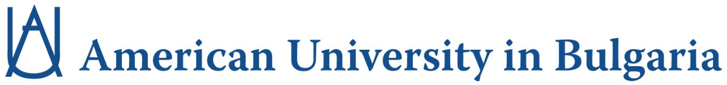

Business Administration State Exam

December 2023

You will be required to answer questions based on material taught in the following courses:

BUS 220 – Financial Accounting

BUS 260 – Marketing

BUS 330 – Corporate Finance

BUS 340 – Organizational Theory and Behaviour

